Using The Exam Generator Program

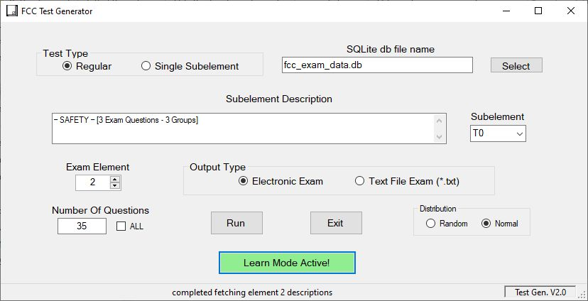

Database File

Start the program. Before you can do anything, you have to load the exam database file into the program. Notice in the upper right area a “Select” button. Click on it and then navigate in the usual manner to wherever you have dropped a copy of the questions database file. Click the “OK” button on the file finder when you’ve located the file. The program will remember where you found it so you don’t have to do this over and over again.

Select the exam element parameters

Look over all the options on the form. First decide which exam you want to run. Element 2 is the Technician class license, 3 is the General class license, and 4 is the Amateur Extra license. On the upper left, select “Regular” or “Single Subelement”. The regular test will randomly select from the entire pool. The subelement type will restrict questions to a particular subelement you choose.

If you decide to concentrate on a single subelement there are two controls in the middle of the form. The dropdown to the right is for choosing and the text box will then display the subject of the subelement.

The “Number of Questions” control is literally for that. You may choose a smaller than normal number or anywhere up to “all”. The initial number displayed is the current requirement value. That is 35 questions for Elements 2 and 3, and 50 for Element 4.

Now select the output type: paper or electronic. Usually it’ll be electronic but you may want to try it on paper which is how the actual exam is done. Follow that up with “Random” or “Normal” for question and answer layout. You can get hung up on question 7 has the answer at D instead of the actual answer. The FCC does not promise to keep the answers in the order shown in the pool so eventually you’ll want to go “Random”.

I have added a “Learn Mode” to this application. When you turn it on it will color the choice box of each question with light green to clearly show the correct answer. Use this initially to get a feel for the correct answers. You still have to click the choice box of each correct answer just like a real test.

Create the Exam

Click the “Run” button. If you chose “Paper” you’ll get the usual printer popup menu. If you choose “Electronic” the exam form will pop up with the first question loaded.

The Electronic Exam 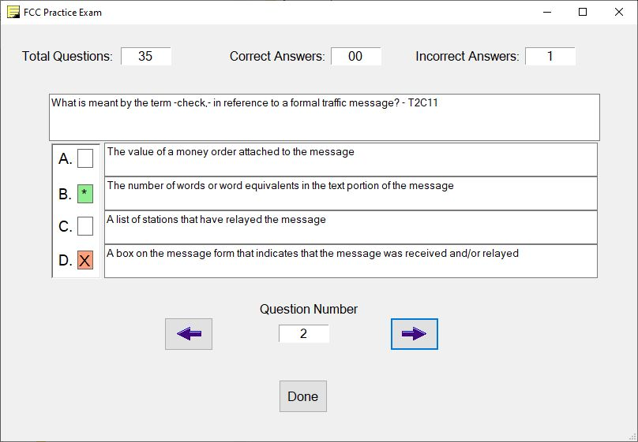

This is what the electronic exam looks like.

Across the top are several obvious progress tracking indicators. Below that is a typical question and the answers, properly called the answer and the distractors. You can see what happens if you answer the question incorrectly. The test will tell you right away and also tell you what is the correct answer so your reinforcement is immediate, increasing learning speed.

At the bottom are the navigation controls. They are just as they seem: next question, previous question, question number, and finally the ‘score me button’ labeled “Done”.

Quitting Early

You may bail out of the program at any time. If you quit early, you’ll get this popup:

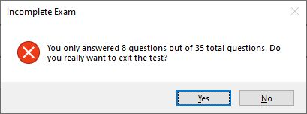

If you actually answered any of the questions you will get the score like this:

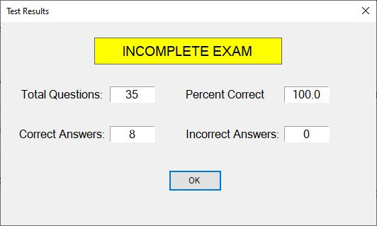

If you answer all the questions and pass you’ll get this popup (I ran a short test to speed up grabbing the screen):

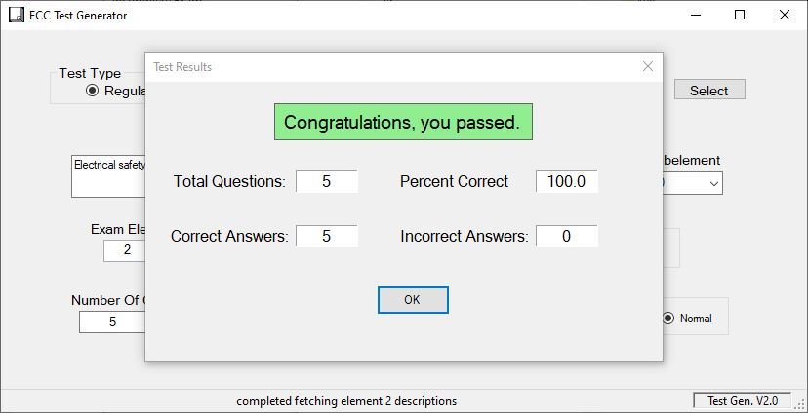

Roundup

That’s all there is to it. Enjoy the software. If you have any suggestions or find any bugs let me know via the project on github. In case you got this from another source like Source Forge here’s the github URL: <https://github.com/stpaulchuck/FCC-Practice-Exam-Generator> .

73’s Charles “Chuck” Fisher – AD0QK

# # #